Gonna Live and Die, NFTY!
Samantha Trattner
“Five! Six! Seven! Eight! Say what’s your name?! Say NFTY!” You’re probably thinking “say what?” I’ll say it again, NFTY! Now you’re probably wondering what NFTY is. NFTY, which stands for the North American Federation of Temple Youth, is the Reform Jewish religious youth movement that promotes leadership at many different levels. Created in 1939, by the Union for Reform Judaism (URJ), NFTY has helped high school students to live and explore Reform Judaism. NFTYites (members of NFTY) build friendships, lifelong Reform Jewish identities, and leadership skills through community building, worship, social action, and experiential youth-led Jewish educational programs.

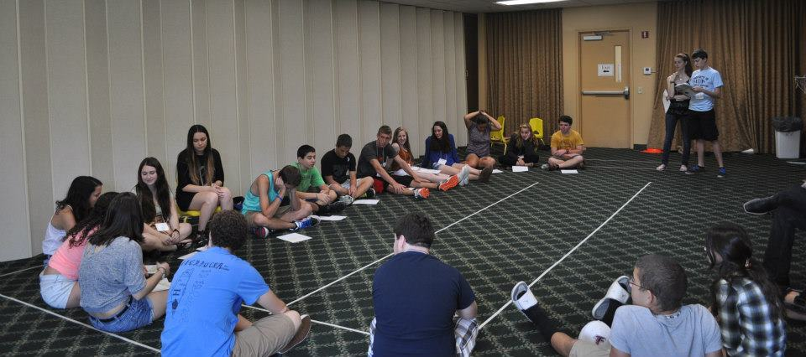
*Program at NFTY-STR Fall Kallah

There are NFTYites all across North America, from Alaska to Florida. The geographic area they live in determines what Region they are a part of. NFTY has 19 regions. Each region has an acronym that reflects the area it’s in for example NFTY-STR is the Southern Tropical Region, and NFTY-TOR is the Texas Oklahoma region. Within these regions are several Temple Youth Groups (TYGs). TYGs also have acronyms that reflect the area they are located in, for example, the name of the TYG located in Orlando, Florida is GORFTY, which stands for the Greater Orlando Federation of Temple Youth.
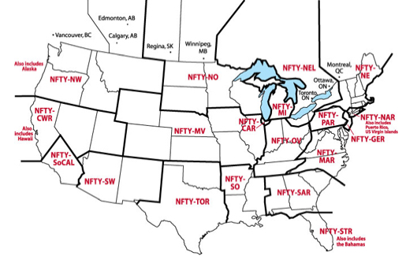
*Directory of Regions

Each region has a board with the following positions President, Programing Vice-President, Social Action Vice-President, Religious and Cultural Vice-President, Membership-and Communications Vice-President (can be split into two positions), and a regional Advisor to help mentor them. There is also the National Board, which are the people who “oversee” all of NFTY. TYGs also have these positions. These board members make all the events possible, whether at it’s a TYG event, Regional event, or National event.
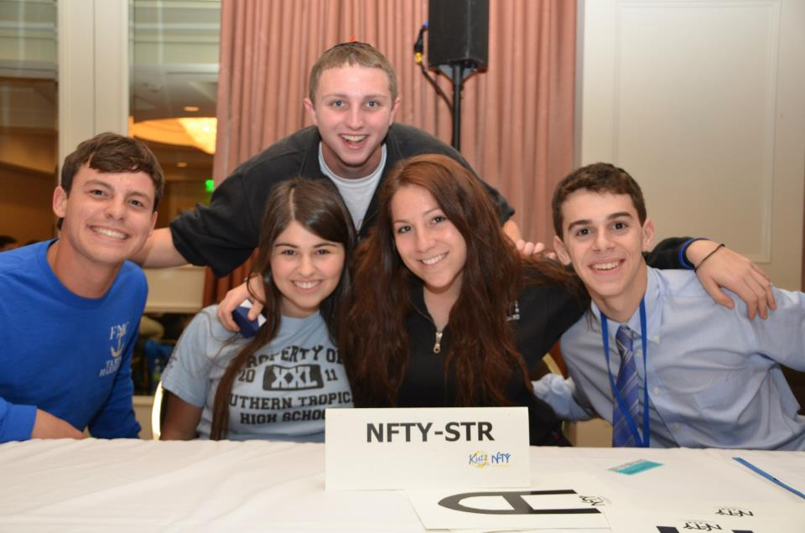
*The NFTY-STR Regional Board

The board members have a lot of responsibilities. From coming up with a theme for each event to recruiting new members, they are always doing something. Another task they have is setting the bar of excitement. They have to keep everyone interested, and excited in what’s going on. What better way to focus a group of people then to do a cheer?
The NFTY Cheer is a cheer that was created for ally NFTYites. It is used at every Kallah, many TYG events, and definitely at NFTY Conventions! I think the purpose of the cheer is to get people excited, to raise energy levels, to make the NFTYites feel like they are a part of something, kind of like a team. A lot of teams have this cheer they do before they go play a game, the NFTY cheer in a way, is like that. Let’s take a look at the words to the cheer!

EVERYONE- Stomp clamp stomp clap stomp clap stomp clap

LEADERS- 5, 6, 7, 8 Say what’s your name?

GROUP- Say NFTY

LEADER- Say what’s your name

GROUP- Say NFTY

LEADER - Say what’s your name?

GROUP- Say NFTY

LEADER- Gonna live and die

ALL- N-F-T-Y

LEADER- NFTY’s in the front

GROUP- Hey hey hey

LEADER- Let me hear you grunt

GROUP- Ho ho ho

LEADER- NFTY’s in the middle

GROUP- Hey hey hey

LEADER- Let me hear you giggle

GROUP- Ha ha ha

LEADER- Never in the rear

GROUP- No no no

LEADER- Let me hear you cheer!

GROUP- Whoooooo!

LEADER- You got it?

GROUP- Yeah!

LEADER- You got it?

GROUP- Yeah!

ALL- It’s in my knees, my knees are weak, it’s in my mouth, I cannot speak, It’s in my hair, it’s over there, it’s over there, it’s everywhere!

Stomp clap stomp clap stomp clap stomp clap

LEADER- 5, 6, 7, 8 Say what’s your name?

GROUP- Say NFTY

LEADER- Say what’s your name

GROUP- Say NFTY

LEADER- Say what’s your name?

GROUP- Say NFTY

LEADER- Gonna live and die

ALL- N-F-T-Y

The cheer changes a little between regions. There is an extra little part that certain regions do, but no two regions do the same thing. Let’s look at NFTY CWR (Central Western Region). They added their own part after the main part of the cheer. It’s really neat to see how each region makes the NFTY cheer their own.
Bump badump ba ba ba bada ba ba ba bada

NFTY CENTRAL WESTERN REGION!!! (x2)

N (clap x3) F (clap x3) T (x3) Y (x3)

C (clap) W (clap) R Hey Hey Hey Hey

C (clap) W (clap) R Hey Hey Hey Hey

Boom sha-wallah wallah boom sha bang bang

Boom sha-wallah wallah

Watch us shake our tushes now!

Bump badump ba ba ba bada

Ba ba ba bada

NFTY CENTRAL WESTERN REGION!!!

The NFTY cheer is done at all Regional and National events, and once in a while, some TYGs do it too because TYG events are put on by the TYG Board. They are either at your Temple, or somewhere the board and advisor decides. Typically the only people who go are the members of the TYG. These events can both be short, and fit in an afternoon like planting trees, and just hanging around, but they can also be overnight events, called Shul-ins or Lock-ins. Typically, Lock-ins have a bunch of different programs. The Board usually tries to plan the night out so that all of the board members lead something. The biggest program that is held at Lock-ins is the Social Action Program.
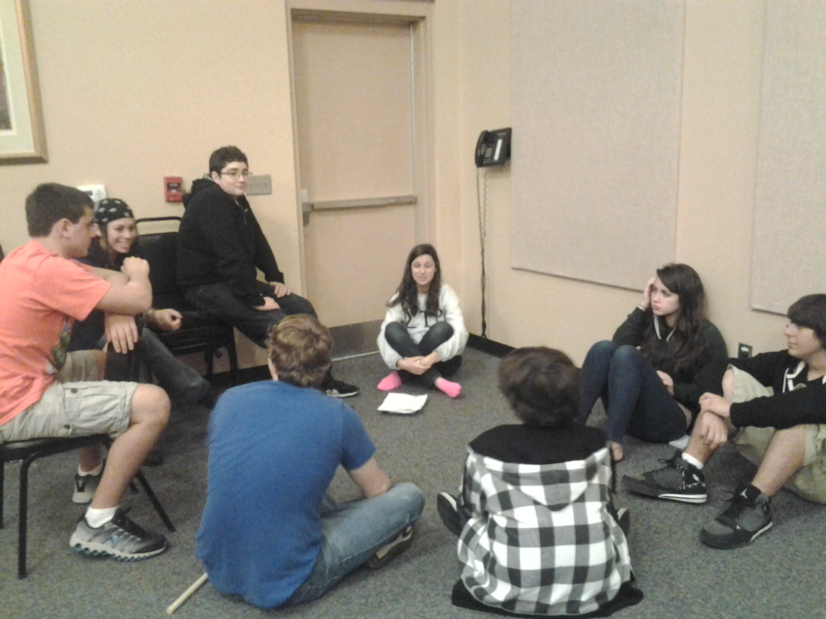
*Discussion groups for the Social Action Program at a GORFTY Lock-in

Regional events, also known as a Kallot (plural) or a Kallah, are usually a bit longer and last between three and five days. The location varies for each Kallah. Every region has at least four Kallot every year, Fall Kallah, Winter Kallah, Spring Kallah, and Hatikvah Kallah (for potential NFTYites, incoming ninth graders). Some regions also have a leadership Kallah, the last one of the year for TYG board members for the coming year. This is also when Songleader auditions are held. Songleaders are very a very important part of NFTY. They work together to plan song sessions, what songs to sing at Siyuum, and they also work closely with the RCVP to plan services.
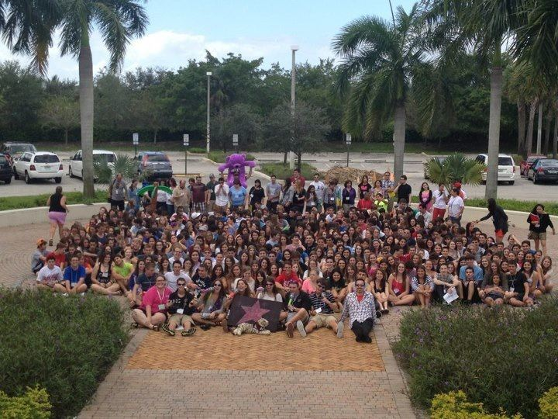
*NFTY-STR Spring Kallah

Every two years, there is a National Convention that NFTYites from all regions attend. Held in different places every year, hundreds of NFTYites gather from all regions for five days jam-packed with educational, social, social action, and religious activities. The most recent one was this past February, 2013, held in LA!
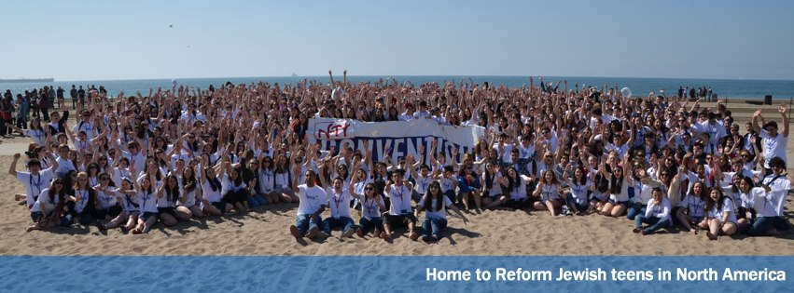
All NFTY events are packed with fun, but there are still rules that have to be followed. Before anyone attends a regional, or national event, they must read and sign the Brit Kehillah. The Brit Kehillah is the Code of conduct that NFTYites must follow when attending an event. It was created for the NFTYites to make them aware of what will and will not be tolerated at events. The Brit is the same for all regions and has probably been tweaked over the years to make it more up-to-date. Things that we have access to now may not have been around 70 years ago when NFTY was created. Before any event, every NFTYite, and their parent or guardian must sign the Brit Kehillah, as a confirmation that they read it. The reason we use the Brit is to insure the health and safety of all participants at NFTY events, and to let it be known what behaviors will not be tolerated.
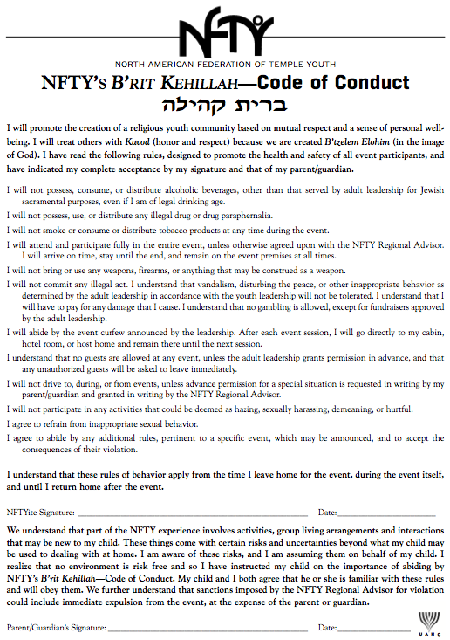
STILL NEED TO WRITE ATRANSITION OF SOME SORT!!!!!!!!!!!
The “Senior Shoe” is a tradition done at the last Siyuum circle at each Kallah during a NFTYite’s senior year. During the closing song, all the seniors take off their shoes, and throw them in the middle of the circle. It was created for senior NFTYites. I think that this tradition represents a journey, a journey through the exploration of ones Judaism. It’s a shoe, it has been worn many places in the past, and will be worn many places in the future, in a way, it is like a marker. It has marked our footprints through life. I think that the reason people do it is to “show” where they have been, where they walked, where they left footprints, and an impact… But because it’s done at the end of the Kallot, I think it symbolizes the closing of one chapter in somebodies life, and the opening/ start of another.
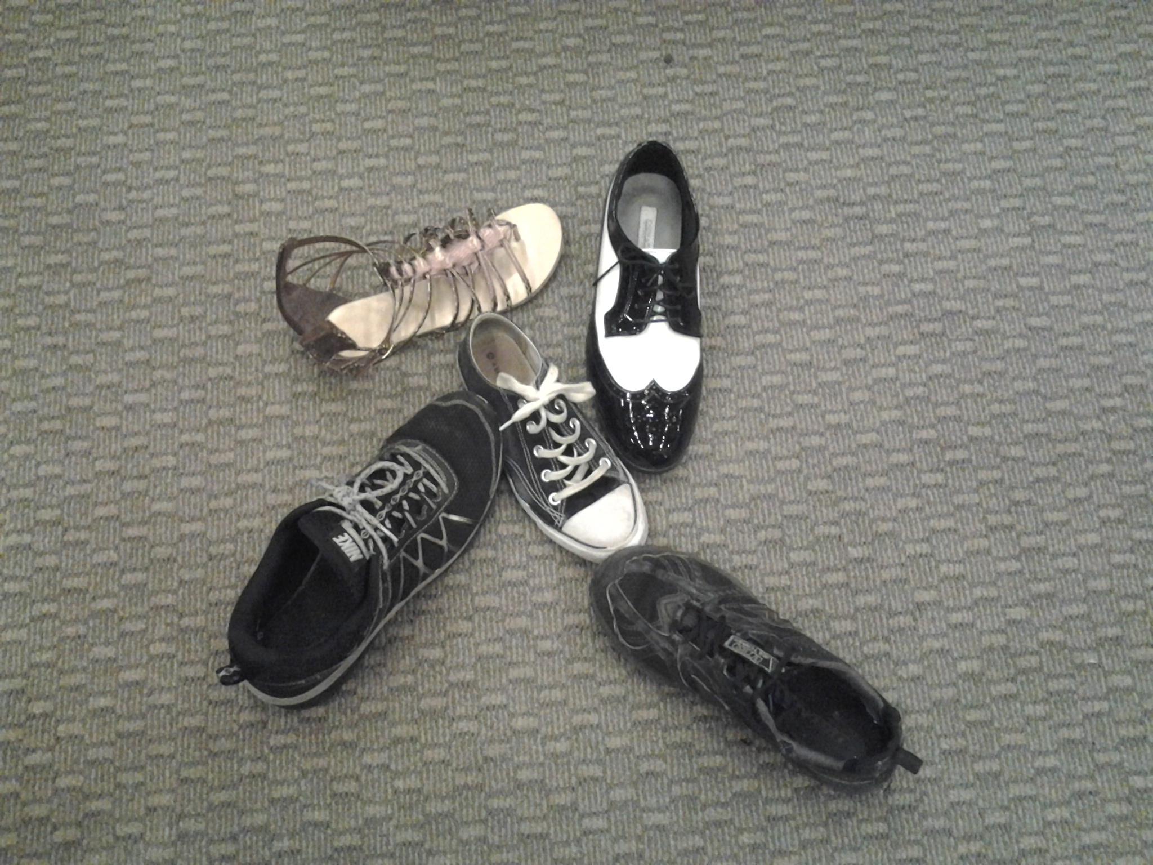
*Senior shoe at GORFTY event

End comments
- Overall I think the community you’ve chosen is very interesting and very intricate!
- The background information you provided were very detailed, but from paragraph 2-4 sounded a bit as if they could be read from NIFTY’s website. They were detailed but a little dry. I’d love to see more YOU in these sections. Maybe you could dress these sections up with a little humor. For example: “The board members have a lot of responsibilities, and man do they work hard. And they’re great people to be around.
- I could not get a sense of what this group meant to you, if you were a part of this group then you could possibly share your own experiences, and talk about more personal things other than just describing what the program does. There were a couple sections in which I did see this. they were noted in the margins.
- Did you want the examples of the cheers to actually be read or are they just there for content? I only skimmed through them.
- An idea for transitions and flow of the paper would be to talk about this community as opposed to describing this community and it’s functions.

