Gonna Live and Die, NFTY!
Samantha Trattner
“Five! Six! Seven! Eight! Say what’s your name?! Say NFTY!” You’re probably thinking “say what?” I’ll say it again, NFTY! Now you’re probably wondering what NFTY is. NFTY (refer to glossary located at the end), which stands for the North American Federation of Temple Youth, is the Reform Jewish religious youth movement that promotes leadership at many different levels. Created in 1939, by the Union for Reform Judaism (URJ), NFTY has helped high school students to live and explore Reform Judaism. NFTYites (members of NFTY) build friendships, lifelong Reform Jewish identities, and leadership skills through community building, worship, social action, and experiential youth-led Jewish educational programs.

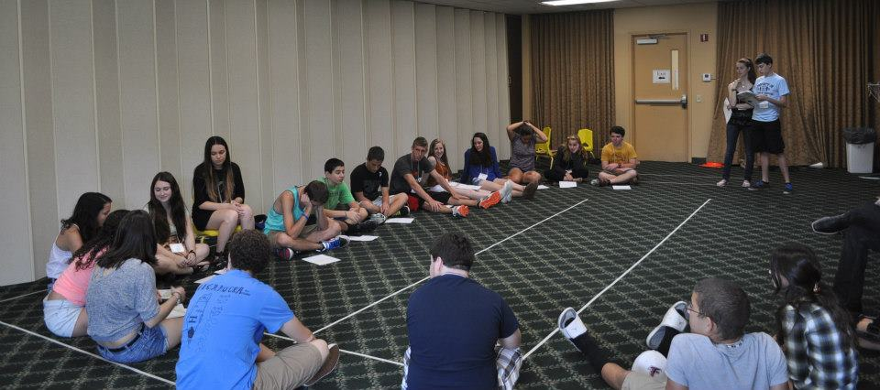
*Program at NFTY-STR Fall Kallah

There are NFTYites all across North America, from Alaska to Florida. The geographic area they live in determines what Region they are a part of. NFTY has 19 regions. Each region has an acronym that reflects the area it’s in for example, NFTY-TOR is the Texas Oklahoma region and NFTY-STR is the Southern Tropical Region (it’s also the best region, but I could just think that because it was my region). Within these regions are several Temple Youth Groups (TYGs). TYGs also have acronyms that reflect the area they are located in, for example, the name of the TYG located in Orlando, Florida is GORFTY, which stands for the Greater Orlando Federation of Temple Youth (it’s also the best TYG).
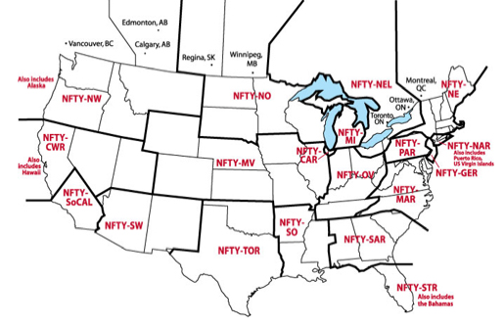
*Directory of Regions

Each region has a board with the following positions President, Programing Vice-President (PVP), Social Action Vice-President (SAVP), Religious and Cultural Vice-President (RCVP), Membership-and Communications Vice-President (MCVP, can be split into two positions), and a regional Advisor to help mentor them. There is also the National Board, which are the people who “oversee” all of NFTY. TYGs also have these positions. These board members make all the events possible, whether it’s at a TYG event, Regional event, or National event.
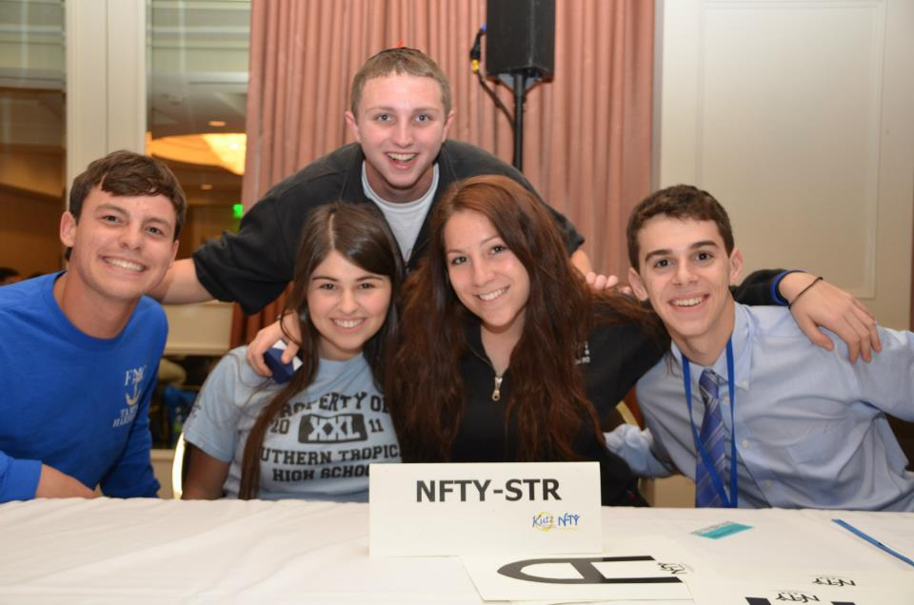
*The NFTY-STR Regional Board 2012-2013

The board members have a lot of responsibilities. From coming up with a theme for each event to recruiting new members, they are always doing something. Another task they have is setting the bar of excitement. They have to keep everyone interested, and excited, in what’s going on. What better way to focus a group of people then to do a cheer?
The NFTY Cheer is a cheer that was created for all NFTYites. It is used at every Kallah, many TYG events, and definitely at NFTY Conventions! I think the purpose of the cheer is to get people excited, to raise energy levels, and to make the NFTYites feel like they are a part of something, kind of like a team. A lot of teams have this cheer they do before they go play a game, the NFTY cheer in a way, is like that. Let’s take a look at the cheer at the 2011 NFTY National Convention!

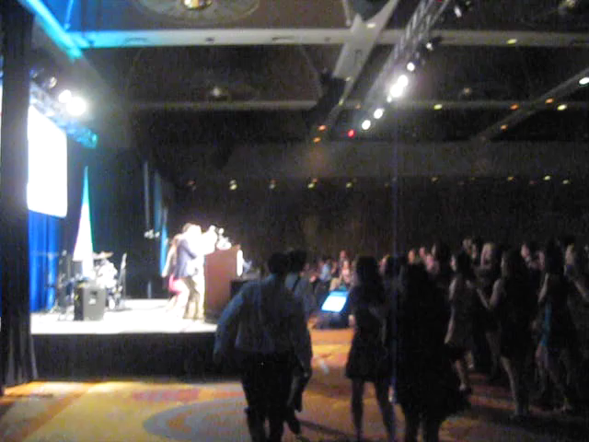

*Video of the NFTY Cheer at the 2011 National Convention
The NFTY cheer is done at all Regional and National events, and once in a while, some TYGs do it too because TYG events are put on by the TYG Board. They are either at your Temple, or somewhere the board and advisor decides. Typically the only people who go are the members of the TYG. These events can both be short, and fit in an afternoon like planting trees, and just hanging around, but they can also be overnight events, called Shul-ins or Lock-ins. Typically, Lock-ins have a bunch of different programs. The Board usually tries to plan the night out so that all of the board members lead something. The biggest program that is held at Lock-ins is the Social Action Program.
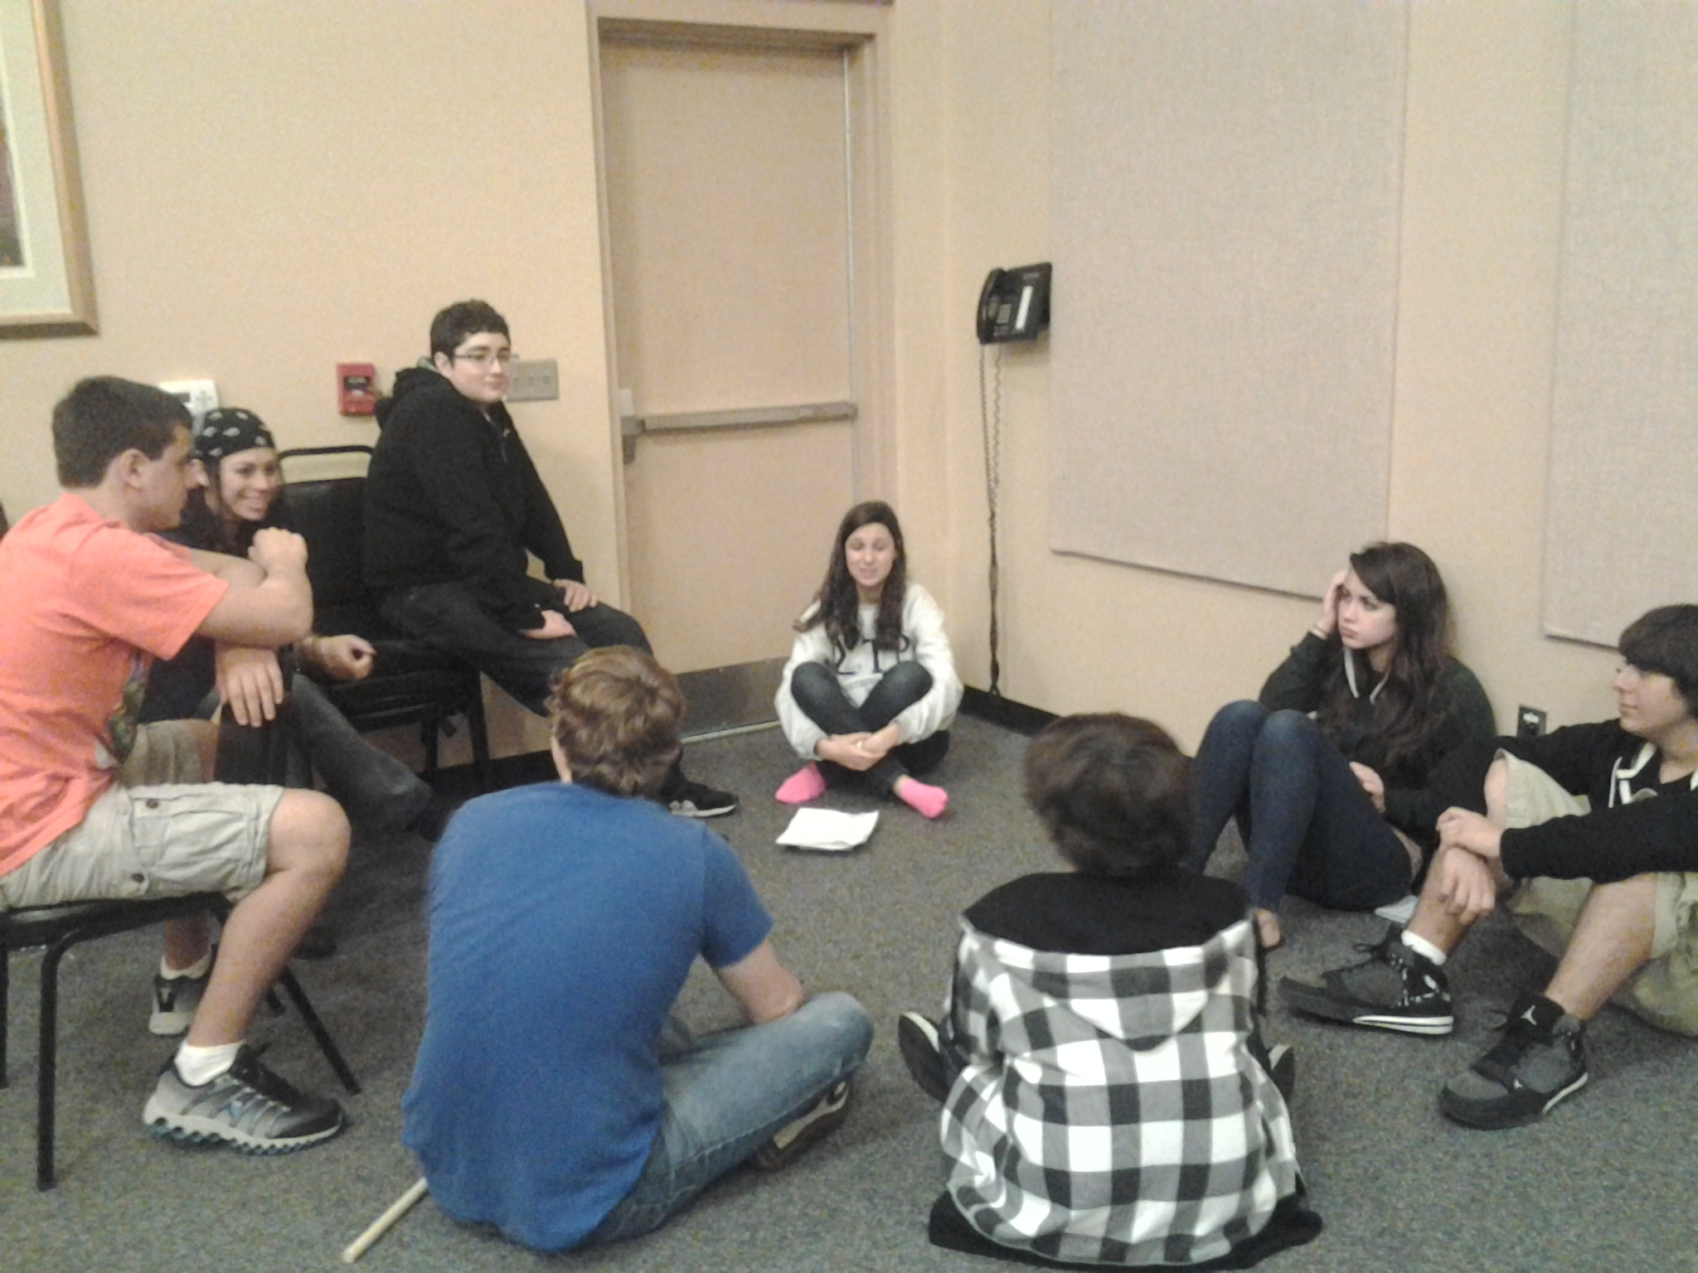
*Discussion groups for the Social Action Program at a GORFTY Lock-in
Regional events, also known as a Kallot (plural) or a Kallah, are usually a bit longer and last between three and five days. The location varies for each Kallah. Every region has at least four Kallot every year, Fall Kallah, Winter Kallah, Spring Kallah, and Hatikvah Kallah (for potential NFTYites, incoming ninth graders).
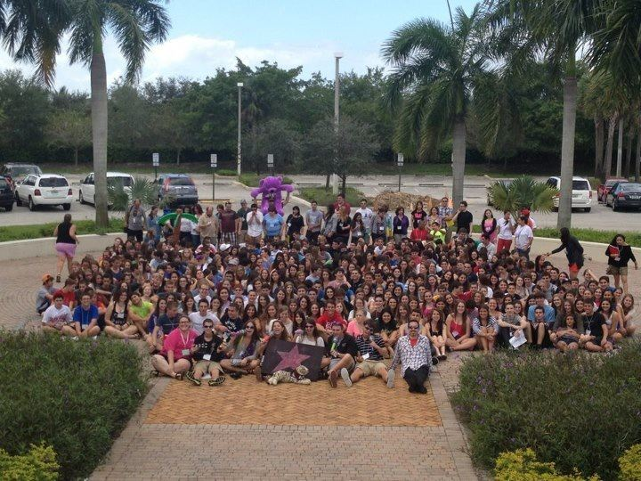
*NFTY-STR Spring Kallah 2012

Kallot are jam-packed with programs and activities, and as you can see in the picture above, there are a lot of people that attend. You might be wondering how everyone knows what they’re supposed to do, where they’re supposed to go, and when they are supposed to do those things and go to those places. Well, there are a couple of ways. One way is by people’s nametags. Nametags are these wonderful things every participant must wear for the duration of any regional or national event. They say your name, your TYG, the Region of the event and the date. On the back of everyone’s nametags, there are program numbers with places the program will take place. This helps all the NFTYites know where to go for each activity. A new nametag is given at each event, so by the time you are a senior, you have accumulated a good number of them, and when you go to your last event, you bring all of the nametags you have received over the years!
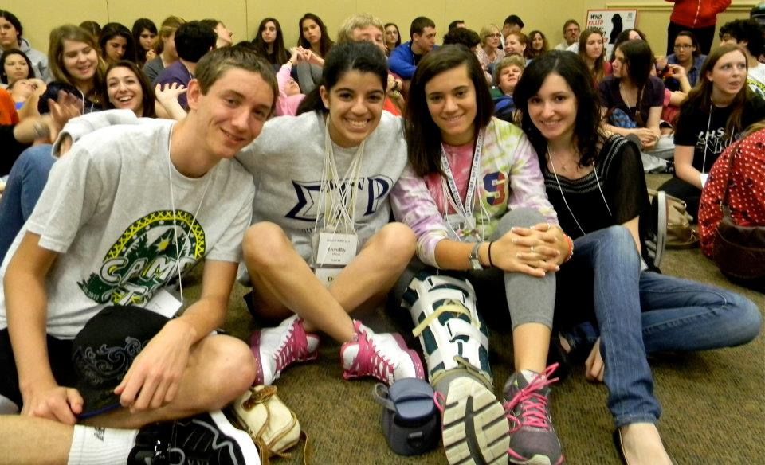
*A couple of seniors with their nametag collection at NFTY-STR Spring Kallah

Another way to keep everything organized is by giving out a daily schedule. Each morning of an event, NFTYites receive a Chai 5. The Chai 5 is in a way like a mini newspaper. It usually has a Sudoku crossword puzzle on it, gives information about the weather, and talks about the day’s happenings. It also has articles written by NFTYites in the region. I think that in a way, the articles are put in the Chai 5 for the newcomers to NFTY. The articles can be about anything the writer wants to talk about. Whether it was a memory, or an experience in NFTY, the articles always reflect how amazing NFTY truly is. I think that is what people want to get across to new NFTYites. I was honored when I was asked to write one for NFTY-STR’s Winter Kallah in 2011.

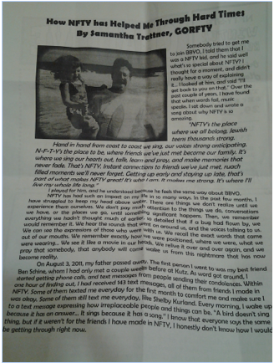
*Chai 5 Article given out at NFTY-STR Winter Kallah 2011

I went to my first Kallah in 2010, NFTY-STR’s Winter Kallah and it was incredible. There was one program in particular that always stuck with me. The girls and boys were separated into different rooms, I’m not quite sure what program the boys did, but I know that the program the girls did stuck with me. We talked about body image, how we are all beautiful. A lot of girls are very insecure about themselves, and in this program, we learned how many other girls feel the same way we do. We were told to stand on one side of the room and there was a white line in the middle. Somebody would read something like “I am uncomfortable with the way I look” or “I think I’m fat.” Then for each statement, if we honestly felt that way about ourselves, we were to walk to the white line and stand on it. The results shocked me. The amount of girls that felt the same about some of these statements was incredible. After all the statements had been read, music was put on, and we were given make up, and we had a party, celebrating our beauty. We then watched a video that had been made interviewing many of the girls in the room about why they felt beautiful, and it was very heartwarming. I wish I had joined NFTY earlier in high school because these people are truly amazing.
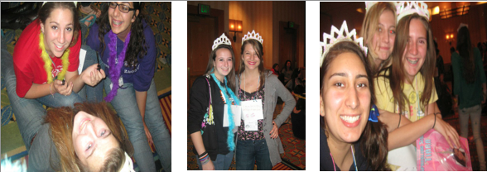
*Body Image Program NFTY-STR Winter Kallah 2011

Some regions also have a leadership Kallah, the last one of the year for TYG board members for the coming year. This is also when Songleader auditions are held. Songleaders are a very important part of NFTY. They work together to plan song sessions, what songs to sing at Siyuum, and they also work closely with the RCVP to plan services. I think that they have the most rewarding job, but again, I could be biased because I am a songleader! Last year, I was the RCVP for my TYG, and the songleader, so I got to work with myself!
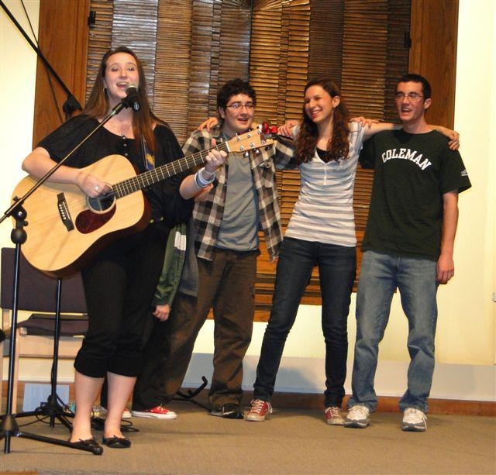
*Songleading with some GORFTY members at Temple

Every two years, there is a National Convention that NFTYites from all regions attend. Held in different places every year, hundreds of NFTYites gather from all regions for five days jam-packed with educational, social, social action, and religious activities. The most recent one was this past February, 2013, held in LA!
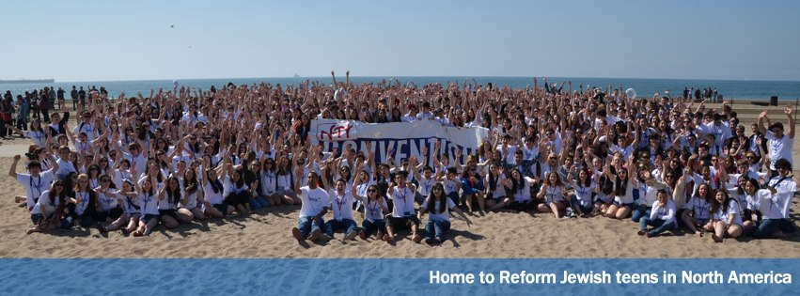
*Picture of all the NFTYites at the 2013 NFTY Convention in LA

Every two years, there are a series of competitions held that any NFTYite can enter, and the winners of each competition are announced at the Convention. There is the Visual Art competition, the Wendy Blickstein Memorial D'var Torah (sermon) Competition, the WRJ Centennial Essay Competition, the NFTY Celebrates Israel at 65 Logo Competition, and the Anselm Rothschild Memorial Song Competition. One of my fondest memories in NFTY was when I won the 2011 Anselm Rothschild Memorial Song Competition, and got to perform it in front of 1000 fellow NFTYites! Check it out!

*Video of 2011 Songwriting Competition Winner.
As you can imagine, all NFTY events are packed with fun, but there are still rules that have to be followed. The Brit Kehillah is the Code of Conduct that NFTYites must follow when attending an event. It was created for the NFTYites to make them aware of what will and will not be tolerated at events and it is the same for all regions. I believe that it is used to insure the health and safety of all participants at NFTY events. It’s possible that it has been tweaked over the years, for example, the first rule is “I will not possess, consume, or distribute alcoholic beverages, other than that served by adult leadership for Jewish sacramental purposes, even if I am of legal drinking age.” Seventy years ago, NFTYites may have been given wine for the blessing we do in services, but nowadays, everyone just gets grape juice so it isn’t even really an issue. Before attending a regional, or national event, every NFTYite, and their parent or guardian, must sign the Brit Kehillah.
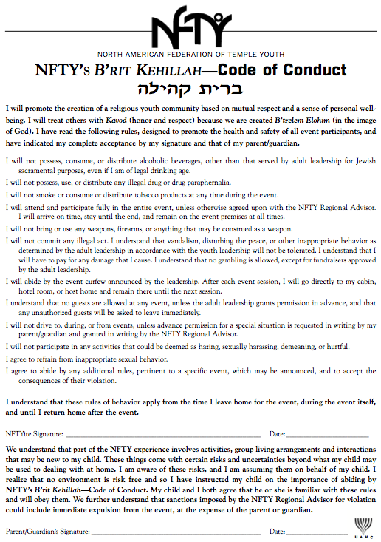
*Picture of the Brit Kehillah
You might now be thinking what’s so special about NFTY? NFTY is so much more than just another youth group; it’s a family. It helps you back up if you fall, and celebrates with you when you accomplish something! It helps you figure out where you stand with things going on in the world. It gives you a voice. It helps you learn, and grow in ways you wouldn’t believe. In case none of what I just said got across to you, I want you to read a part of a poem. I am not sure who wrote it, but I think that it truly captures what it means to be a NFTYite.
To be a NFTYite.
To make better friends in three days than you've made in three years.
To fall in love, to have someone break your heart.
To break someone else's.

To be a NFTYite.
To have opinions about everything, yet still possess an open mind.
To participate in discussions more challenging than anything you've ever encountered at school.
To know that, even though we disagree, we are still the best of friends.

To be a NFTYite.
To struggle with what it means to be a Jew.
To wrestle with God and the Torah.
To understand that both struggling and wrestling are
The highest Jewish virtues.

To be a NFTYite.
To sing Jewish music at the top of your lungs.
To know that if your school friends saw you,
They would roll over laughing.
To not care.

To be a NFTYite.
To know that a sore throat from singing your heart out
Is the greatest feeling in the world.
To lose yourself in a community.
To find yourself within.
To share your soul with others.

To be a NFTYite.
To know that the words "and our youth shall see visions"
Are more than just a song.
To know that the words "gonna live and die N-F-T-Y”
Are more than just a cheer.
To know that the word "goodbye" is merely a code for
"see you later."

To be a NFTYite.
To know that NFTY won't last forever.
To still cry when it finally ends.
To be surrounded by loved ones when the time comes to leave.

To be a NFTYite.
To understand the power of smiling at a stranger.
To know how powerful remembering someone's name is.
To have been both smiled at and remembered by strangers.

To be a NFTYite.
To look up to your regional leaders your freshman year,
To wonder why you're being looked up to your senior year.
To look back and realize how much you've grown.

NFTY stays with you forever, even when you graduate and go to college. I talk to more people from NFTY, that I spent maybe a total of 3 months with over the past two years, than I talk to from my high school where I was almost every day for four years. Just because one chapter in your life closes, doesn’t mean that you won’t still refer back to that chapter later. This brings me to the wonderful tradition that senior NFTYites do.
The “Senior Shoe” is a tradition done at the last Siyuum circle at each Kallah during a NFTYite’s senior year. During the closing song, all the seniors take off their shoes and throw them in the middle of the circle. It was created for senior NFTYites. I think that this tradition represents a journey, a journey through the exploration of ones Judaism. It’s a shoe, it has been worn many places in the past, and will be worn many places in the future, in a way, it is like a marker. It has marked our footprints through life. I think that the reason people do it is to “show” where they have been, where they walked, where they left footprints, and an impact… But because it’s done at the end of the Kallot, I think it symbolizes the closing of one chapter in somebodies life, and the opening/ start of another.
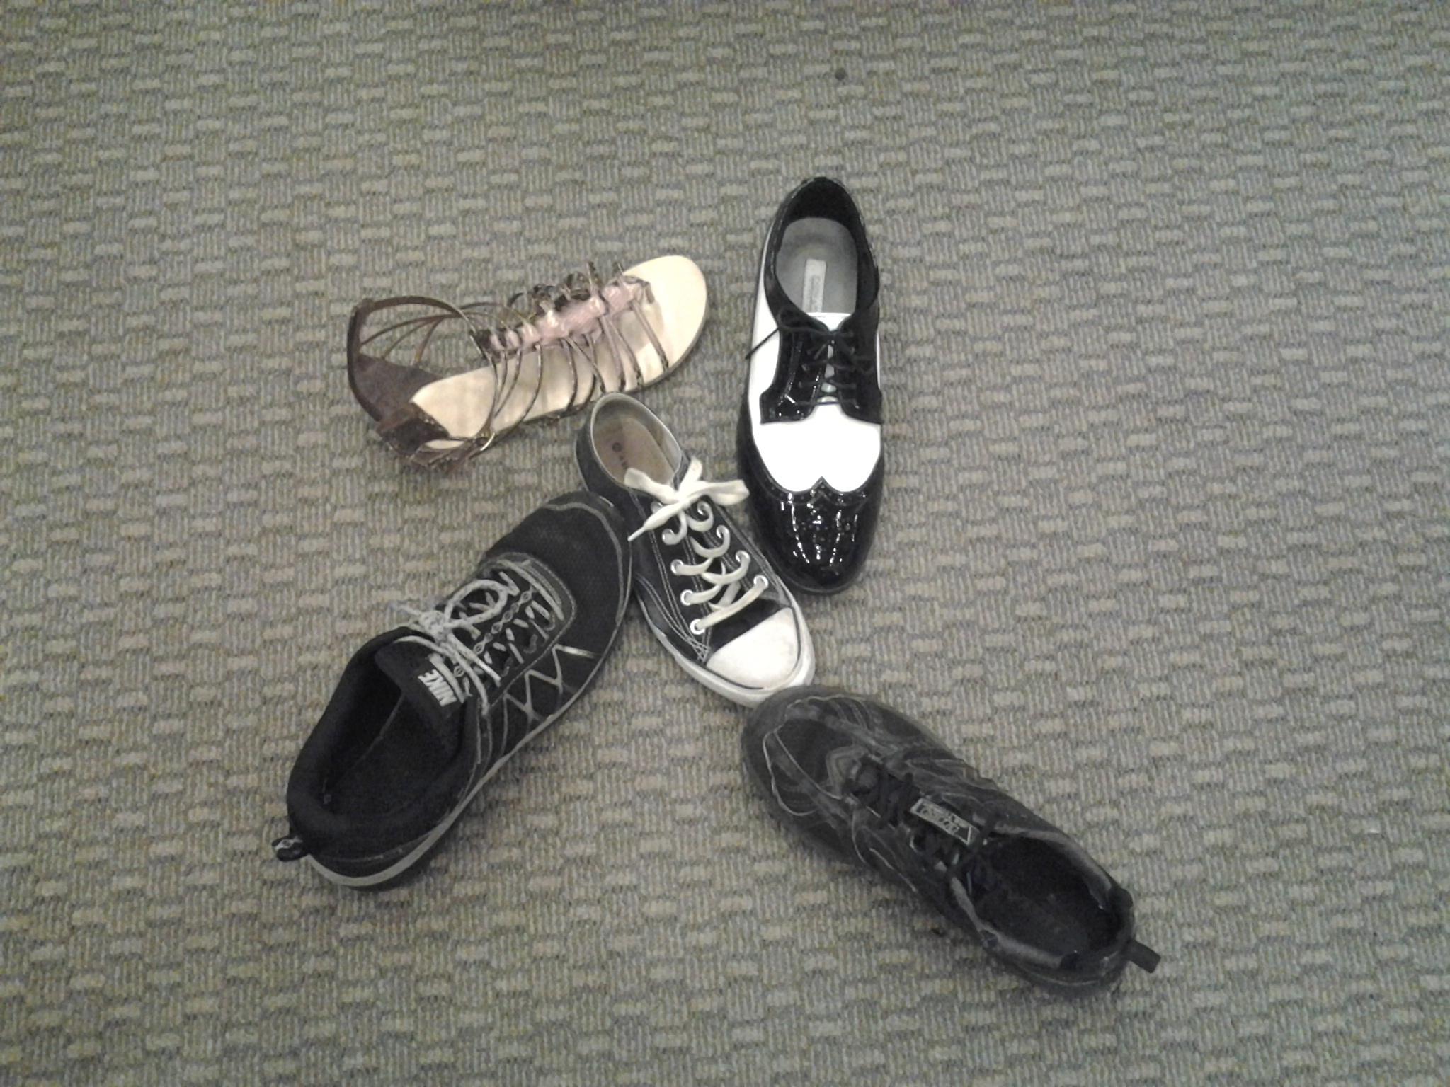
*Senior shoe at GORFTY event

Glossary

Advisor- Adults who advise and mentor our youth in programming, logistics, administrative work, and leadership skills. Every TYG has an advisor, as does every region.

Board- Both TYG, and Regional, made up of the following positions, President, Programing Vice-President, Social Action Vice-President, Religious and Cultural Vice-President, Membership-and Communications Vice-President.

Brit Kehillah- The Code of Conduct (insures the health and safety of all participants at NFTY events).

Hatikvah Kallah- Kallah for potential NFTYites, who will be 8th graders.

Kallah/ Kallot- Fun weekends when NFTYites from all different TYGs in a particular region come together to meet other NFTYites, to pray and learn. There are typically at least four Kallot every year, Fall Kallah, Winter Kallah, Spring Kallah, and LLTI, which is a leadership training Kallah. There is also Hatikvah Kallah, which is for potential NFTYites who are about to enter high school.

Kutz Camp – NFTY’s summer home that offers Leadership Academies during the summer where students entering grades 9-12 can develop leadership skills, gain Jewish knowledge, take part in religious action, and creative arts.

MCVP- Membership and Communications Vice President. The TYG board position that communicates and advertises all programs and events (both locally and regionally) for the TYG. This position primarily is in charge of mixers and welcoming type of programming for the TYG
Mixers- (Ice Breakers) Activities done at the beginning of events to help people get to know other people.

NFTY- The North American Federation of Temple Youth. Anyone who pays membership to Temple Youth Group is part of NFTY.

NFTYite- The name for a participant in NFTY.

NFTY (National) Convention - 5 day gathering of NFTY-ites from all over North America during which educational, social, social action, and religious activities are scheduled.
President: The TYG Board position that organizes, delegates, and communicates with the TYG, the board, the NFTY region, and the advisor.
Program - An educational, social, religious, or social action activity planned by youth group members; programs can included any number of elements of implementation such as role-playing, skits, games, group discussions, artistic interpretation, etc.

PVP- Programming Vice President. This TYG board position primarily is in charge of programming (or the development of programming) for the TYG
RCVP- Religious and Cultural Vice President. The TYG Board position who deals with all the rituals and traditions that Reform Judaism holds, programming for the TYG and conveys them in an interesting and creative manner to the TYG. This position oversees the services and is primarily in charge of cultural aspects.
Region: A region encompasses all the TYGs that fall in a certain geographic area. NFTY has 19 regions. Each region has an acronym that reflects the area it’s in, for example: NFTY-STR is the Southern Tropical Region, and NFTY-TOR is the Texas Oklahoma region.
Ruach: That means “spirit” and boy do NFTYites have a lot of it! Just take a look at our song sessions, our programs, and our services.
Siyuum- Circle at the end of the day or at the end of an event where we talk about our experiences and sing a couple of songs before bed, or the end of the Kallah.

SAVP- Social Action Vice President. The TYG board position who makes us all aware of the social issues in our community, the Reform movement, and NFTY. This person primarily is in charge of social action type of programming for the TYG.
Social Action Program: A program at a TYG, Regional, or National event where NFTYites get together to talk about current issues in the world, like bullying, or global warming, or do community service such as Habitat for Humanity, build baskets for hospital patients, make sandwiches for a homeless shelter, or raise money for other organizations.
Songleader- (Usually falls under the responsibility of the RCVP in a TYG) Amazing NFTYites that lead everyone in song sessions which can take place after a meal or programs and often lead everyone in services.

Song Session: A time for singing with your fellow NFTYites. This is usually planned after lunch or dinner during a TYG or NFTY event. NFTYites sing and dance during the session!
TYG- Temple Youth Group. This is the group you join to become a member of a region, which in turn gives you membership to a NFTY region.
URJ: Union for Reform Judaism. The URJ is the parent body of NFTY. The URJ provides financial, adult, clergy, and educational support to NFTY.

