Gonna Live and Die, NFTY!
Samantha Trattner
“Five! Six! Seven! Eight! Say what’s your name?! Say NFTY!” You’re probably thinking “say what?” I’ll say it again, NFTY! Now you’re probably wondering what NFTY is. NFTY, which stands for the North American Federation of Temple Youth, is the Reform Jewish religious youth movement that promotes leadership at many different levels. Created in 1939, by the Union for Reform Judaism (URJ), NFTY has helped high school students to live and explore Reform Judaism. NFTYites (members of NFTY) build friendships, lifelong Reform Jewish identities, and leadership skills through community building, worship, social action, and experiential youth-led Jewish educational programs.

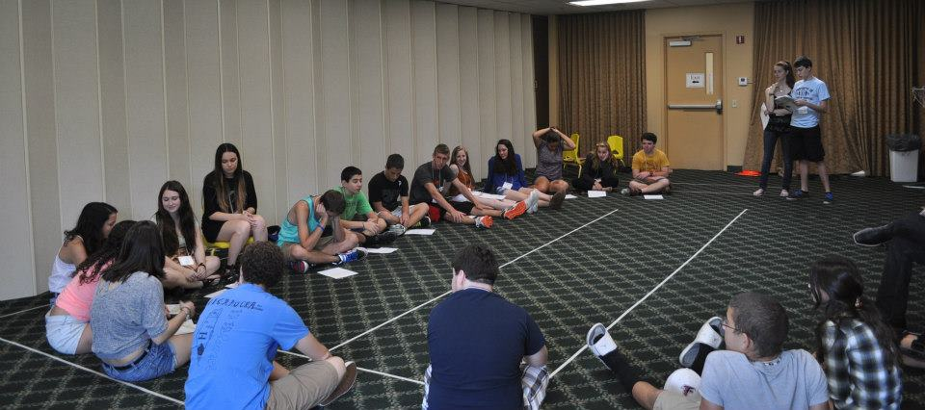
*Program at NFTY-STR Fall Kallah

There are NFTYites all across North America, from Alaska to Florida. The geographic area they live in determines what Region they are a part of. NFTY has 19 regions. Each region has an acronym that reflects the area it’s in for example, NFTY-TOR is the Texas Oklahoma region and NFTY-STR is the Southern Tropical Region (it’s also the best region, but I could just think that because it was my region). Within these regions are several Temple Youth Groups (TYGs). TYGs also have acronyms that reflect the area they are located in, for example, the name of the TYG located in Orlando, Florida is GORFTY, which stands for the Greater Orlando Federation of Temple Youth (it’s also the best TYG).
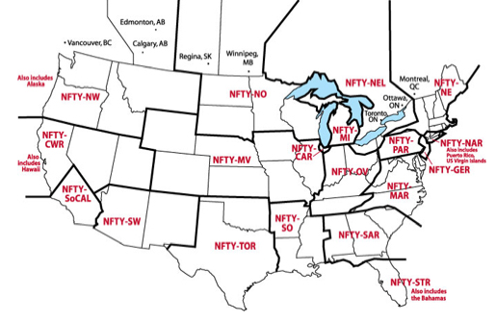
*Directory of Regions

Each region has a board with the following positions President, Programing Vice-President (PVP), Social Action Vice-President (SAVP), Religious and Cultural Vice-President (RCVP), Membership-and Communications Vice-President (MCVP, can be split into two positions), and a regional Advisor to help mentor them. There is also the National Board, which are the people who “oversee” all of NFTY. TYGs also have these positions. These board members make all the events possible, whether at it’s a TYG event, Regional event, or National event.
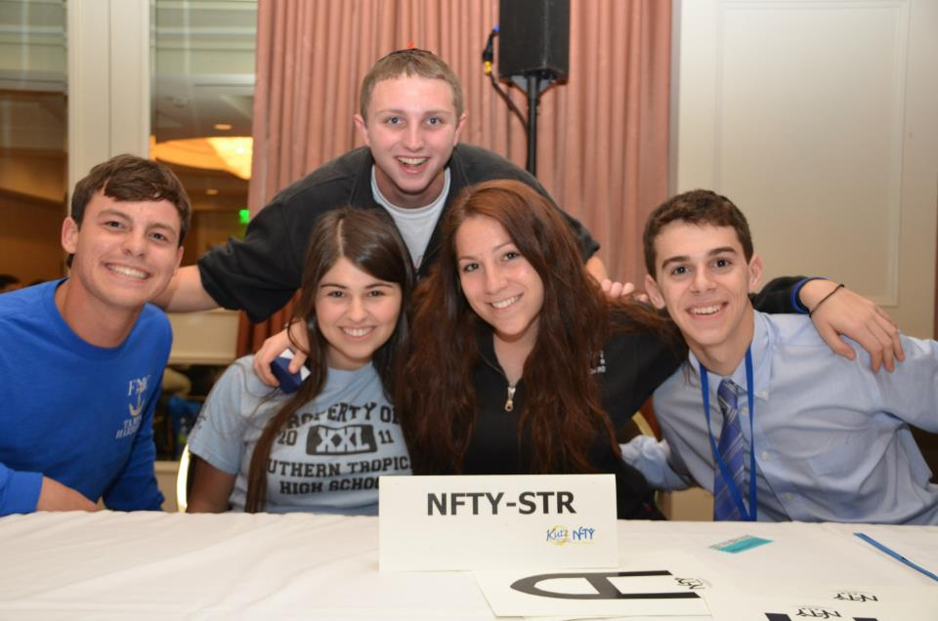
*The NFTY-STR Regional Board 2012-2013

The board members have a lot of responsibilities. From coming up with a theme for each event to recruiting new members, they are always doing something. Another task they have is setting the bar of excitement. They have to keep everyone interested, and excited in what’s going on. What better way to focus a group of people then to do a cheer?
The NFTY Cheer is a cheer that was created for ally NFTYites. It is used at every Kallah, many TYG events, and definitely at NFTY Conventions! I think the purpose of the cheer is to get people excited, to raise energy levels, to make the NFTYites feel like they are a part of something, kind of like a team. A lot of teams have this cheer they do before they go play a game, the NFTY cheer in a way, is like that. Let’s take a look at the cheer at the 2011 NFTY National Convention!

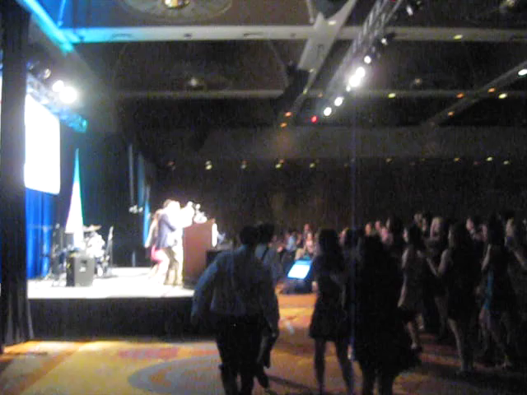

*Video of the NFTY Cheer at the 2011 National Convention
The NFTY cheer is done at all Regional and National events, and once in a while, some TYGs do it too because TYG events are put on by the TYG Board. They are either at your Temple, or somewhere the board and advisor decides. Typically the only people who go are the members of the TYG. These events can both be short, and fit in an afternoon like planting trees, and just hanging around, but they can also be overnight events, called Shul-ins or Lock-ins. Typically, Lock-ins have a bunch of different programs. The Board usually tries to plan the night out so that all of the board members lead something. The biggest program that is held at Lock-ins is the Social Action Program.
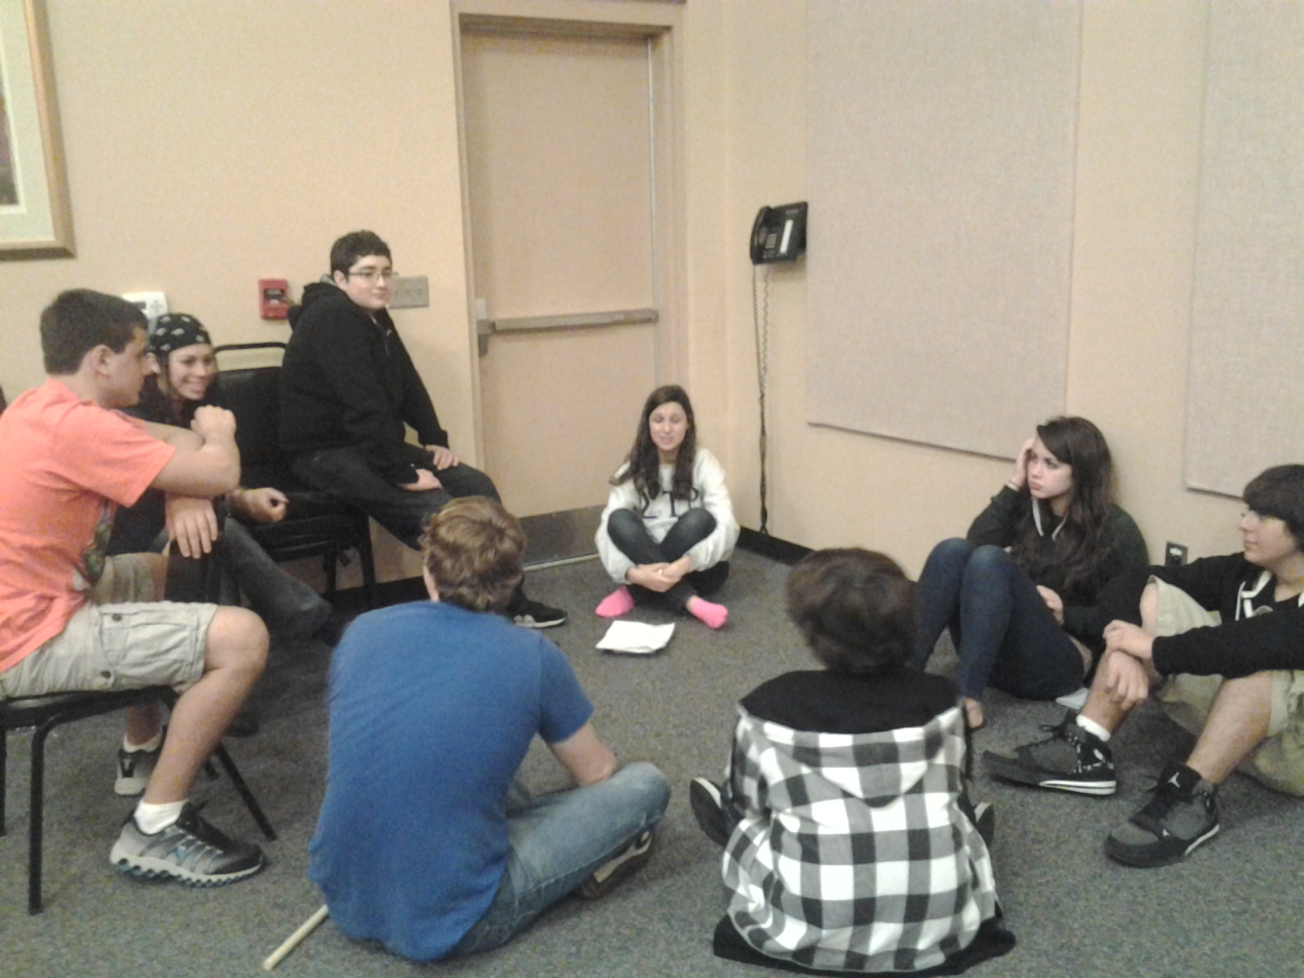
*Discussion groups for the Social Action Program at a GORFTY Lock-in
Regional events, also known as a Kallot (plural) or a Kallah, are usually a bit longer and last between three and five days. The location varies for each Kallah. Every region has at least four Kallot every year, Fall Kallah, Winter Kallah, Spring Kallah, and Hatikvah Kallah (for potential NFTYites, incoming ninth graders).
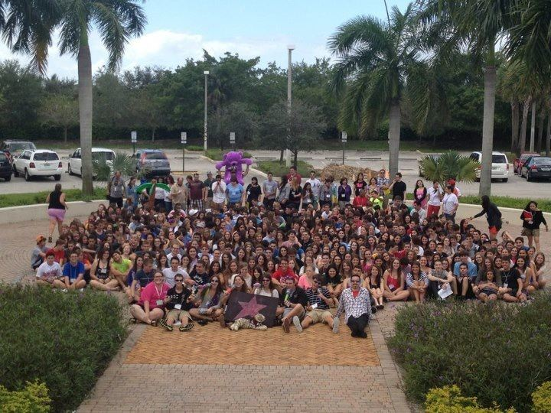
*NFTY-STR Spring Kallah 2012

I went to my first Kallah in 2011, NFTY-STR’s Winter Kallah and it was incredible. There was one program in particular that always stuck with me. The girls and boys were separated into different rooms, I’m not quite sure what program the boys did, but I know that the program the girls did stuck with me. We talked about body image, how we are all beautiful. A lot of girls are very insecure about themselves, and in this program, we learned how many other girls feel the same way we do. We were told to stand on one side of the room and there was a white line in the middle. Somebody would read something like “I am uncomfortable with the way I look” or “I think I’m fat.” Then for each statement, if we honestly felt that way about ourselves, we were to walk to the white line and stand on it. The results shocked me. The amount of girls that felt the same about some of these statements was incredible. After all the statements had been read, music was put on, and we were given make up, and we had a party, celebrating our beauty. We then watched a video that had been made interviewing many of the girls in the room about why they felt beautiful, and it was very heartwarming. I wish I had joined NFTY earlier in high school because these people are truly amazing.
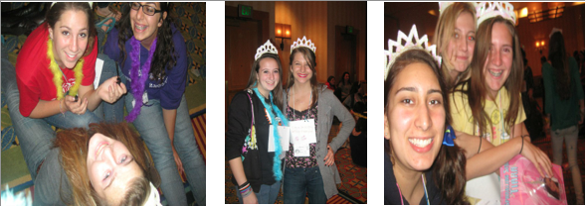
*Body Image Program NFTY-STR Winter Kallah 2011

Some regions also have a leadership Kallah, the last one of the year for TYG board members for the coming year. This is also when Songleader auditions are held. Songleaders are very a very important part of NFTY. They work together to plan song sessions, what songs to sing at Siyuum, and they also work closely with the RCVP to plan services. I think that they have the most rewarding job, but again, I could be biased because I am a songleader! Last year, I was the RCVP for my TYG, and the songleader, so I got to work with myself!
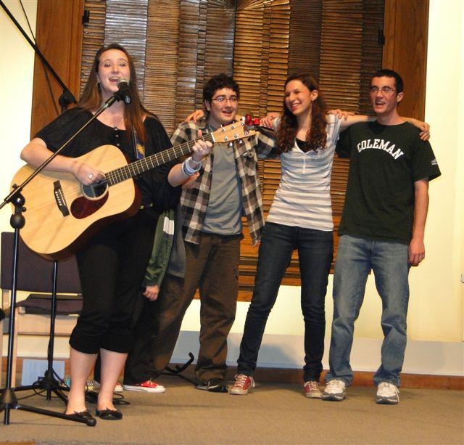
*Songleading with some GORFTY members at Temple

Every two years, there is a National Convention that NFTYites from all regions attend. Held in different places every year, hundreds of NFTYites gather from all regions for five days jam-packed with educational, social, social action, and religious activities. The most recent one was this past February 2013, held in LA!
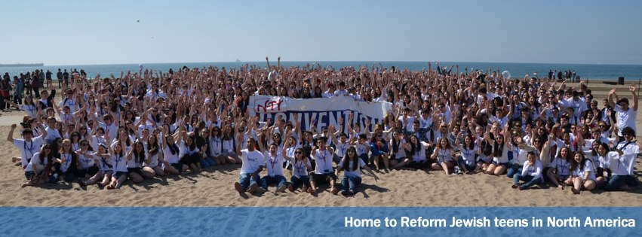
Every two years, there are a series of competitions held that any NFTYite can enter, and the winners of each competition are announced at the Convention. There is the Visual Art competition, the Wendy Blickstein Memorial D'var Torah (sermon) Competition, the WRJ Centennial Essay Competition, the NFTY Celebrates Israel at 65 Logo Competition, and the Anselm Rothschild Memorial Song Competition. One of my fondest memories in NFTY was when I won the 2011 Anselm Rothschild Memorial Song Competition, and got to perform it in front of 1000 fellow NFTYites! Check it out!

*Video of 2011 Songwriting Competition Winner.
As you can imagine, all NFTY events are packed with fun, but there are still rules that have to be followed. The Brit Kehillah is the Code of conduct that NFTYites must follow when attending an event. It was created for the NFTYites to make them aware of what will and will not be tolerated at events and it is the same for all regions. I believe that it is used insure the health and safety of all participants at NFTY events. It’s possible that it has been tweaked over the years, for example, the first rule is “I will not possess, consume, or distribute alcoholic beverages, other than that served by adult leadership for Jewish sacramental purposes, even if I am of legal drinking age.” Seventy years ago, NFTYites may have been given wine for the blessing we do in services, but nowadays, everyone just gets grape juice so it isn’t even really an issue. Before attending a regional, or national event, every NFTYite, and their parent or guardian must sign the Brit Kehillah.
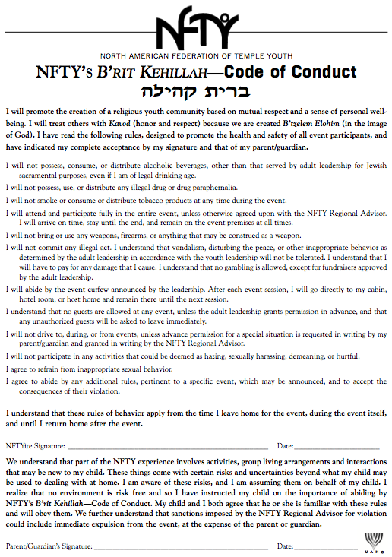
*Picture of the Brit Kehillah
You might now be thinking what’s so special about NFTY? NFTY is so much more than just another youth group it’s a family. It helps you back up if you fall, and celebrates with you when you accomplish something! It helps you figure out where you stand with things going on in the world. It gives you a voice. It helps you learn, and grow in ways you wouldn’t believe. In case none of what I just said got across to you, I want you to read a part of a poem. I am not sure who wrote it, but I think that it truly captures what it means to be a NFTYite.
To be a NFTYite.
To make better friends in three days than you've made in three years.
To fall in love, to have someone break your heart.
To break someone else's.

To be a NFTYite.
To have opinions about everything, yet still possess an open mind.
To participate in discussions more challenging than anything you've ever encountered at school.
To know that, even though we disagree, we are still the best of friends.

To be a NFTYite.
To struggle with what it means to be a Jew.
To wrestle with God and the Torah.
To understand that both struggling and wrestling are
The highest Jewish virtues.

To be a NFTYite.
To sing Jewish music at the top of your lungs.
To know that if your school friends saw you,
They would roll over laughing.
To not care.

To be a NFTYite.
To know that a sore throat from singing your heart out
Is the greatest feeling in the world.
To lose yourself in a community.
To find yourself within.
To share your soul with others.

To be a NFTYite.
To know that the words "and our youth shall see visions"
Are more than just a song.
To know that the words "gonna live and die N-F-T-Y”
Are more than just a cheer.
To know that the word "goodbye" is merely a code for
"see you later."

To be a NFTYite.
To know that NFTY won't last forever.
To still cry when it finally ends.
To be surrounded by loved ones when the time comes to leave.

To be a NFTYite.
To understand the power of smiling at a stranger.
To know how powerful remembering someone's name is.
To have been both smiled at and remembered by strangers.

To be a NFTYite.
To look up to your regional leaders your freshman year,
To wonder why you're being looked up to your senior year.
To look back and realize how much you've grown.

NFTY stays with you forever, even when you graduate and go to college. I talk to more people from NFTY, that I spent maybe a total of 3 months with over the past two years than I talk to from my high school where I was almost every day for four years. Just because one chapter in your life closes, doesn’t mean that you won’t still refer back to that chapter later. This brings me to the wonderful tradition that senior NFTYites do.
The “Senior Shoe” is a tradition done at the last Siyuum circle at each Kallah during a NFTYite’s senior year. During the closing song, all the seniors take off their shoes, and throw them in the middle of the circle. It was created for senior NFTYites. I think that this tradition represents a journey, a journey through the exploration of ones Judaism. It’s a shoe, it has been worn many places in the past, and will be worn many places in the future, in a way, it is like a marker. It has marked our footprints through life. I think that the reason people do it is to “show” where they have been, where they walked, where they left footprints, and an impact… But because it’s done at the end of the Kallot, I think it symbolizes the closing of one chapter in somebodies life, and the opening/ start of another.
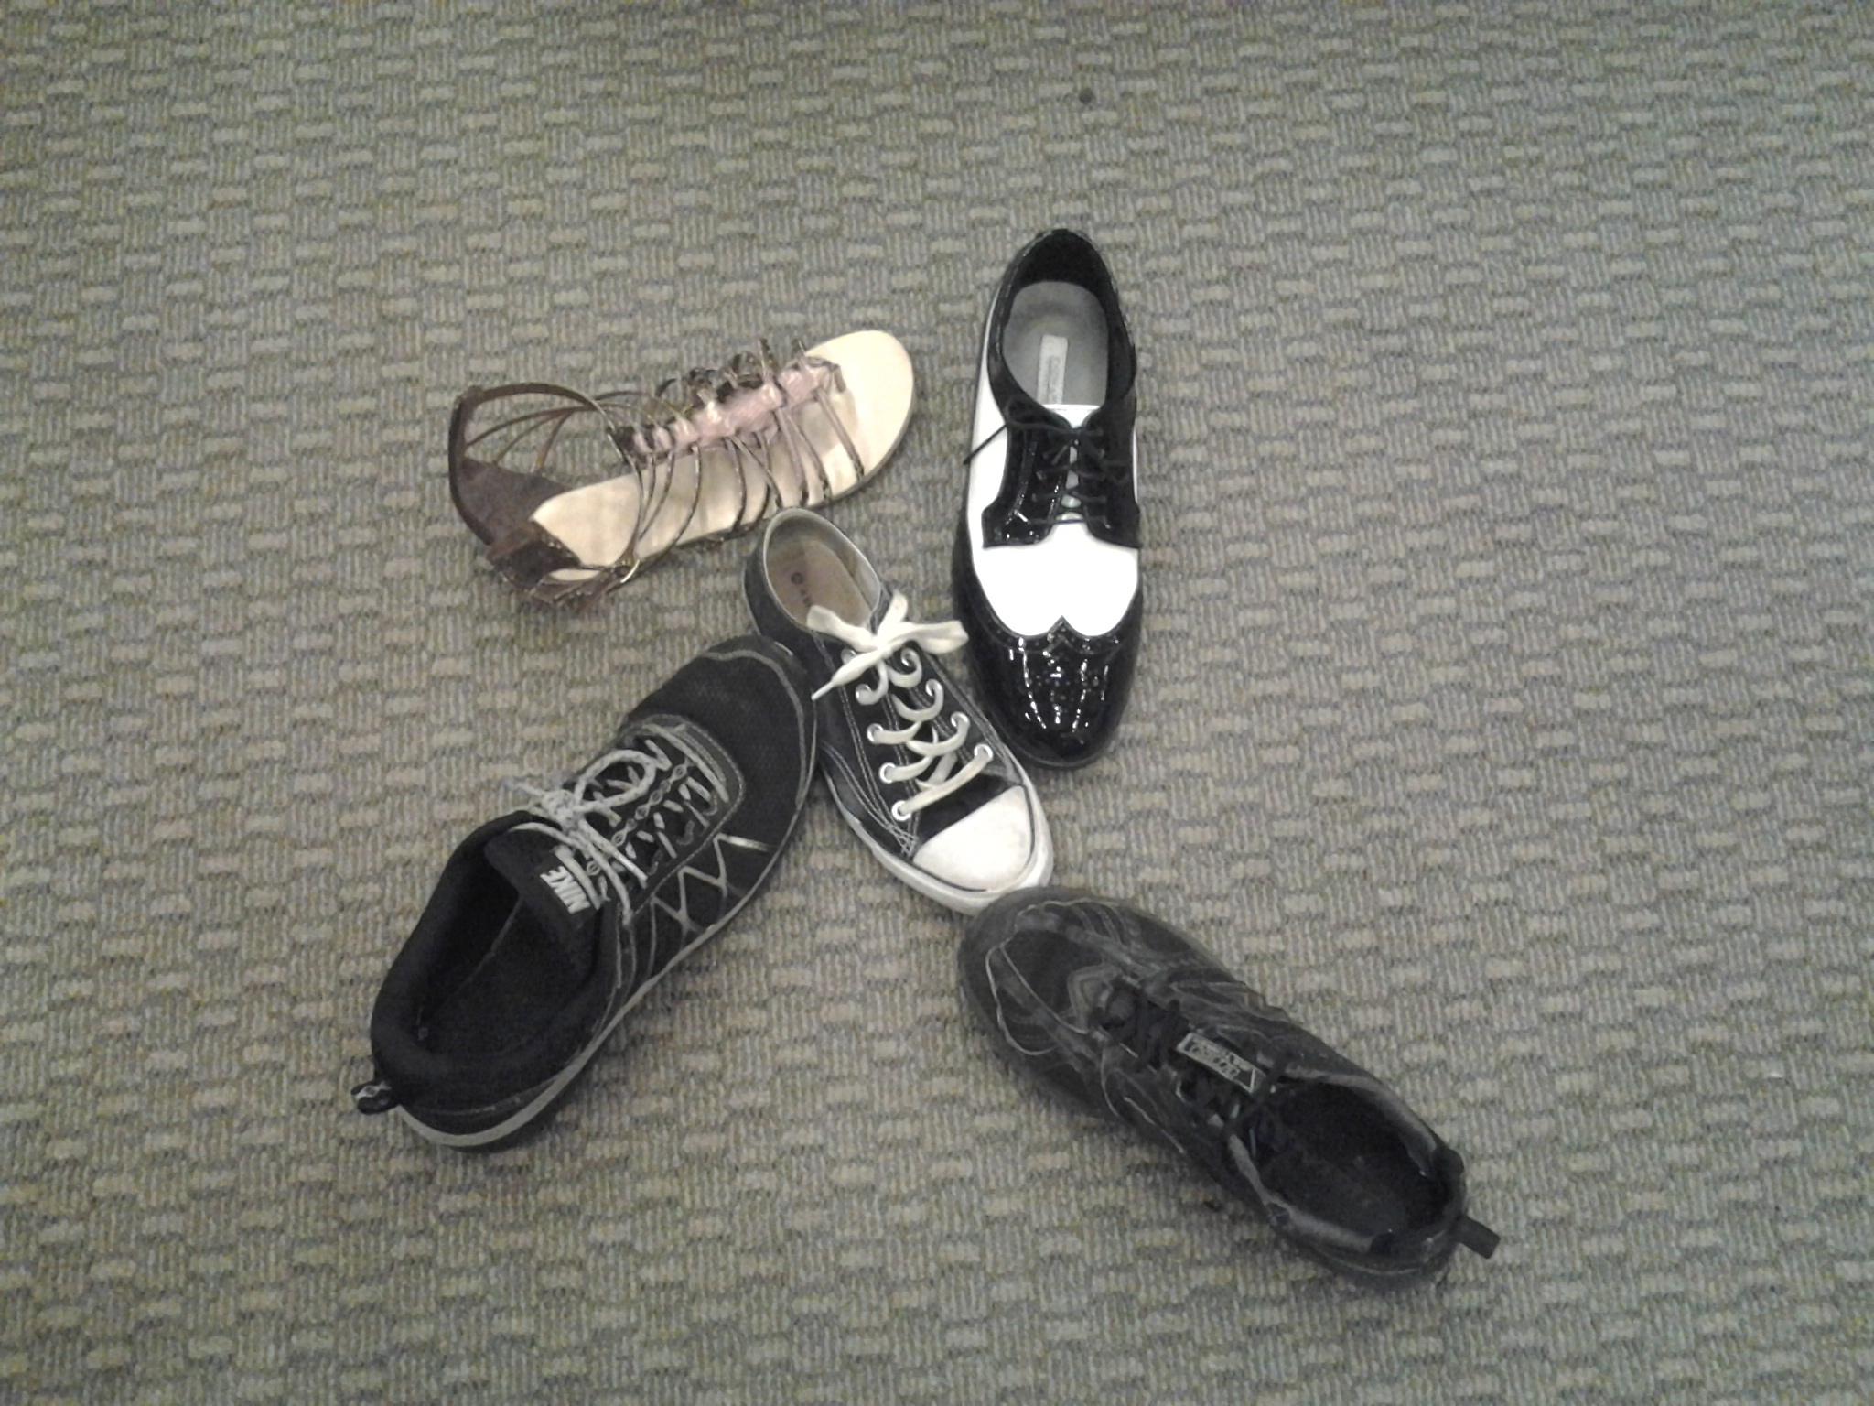
*Senior shoe at GORFTY event

