Artifact Analysis
Samantha Trattner

NFTY Cheer

What is it?
-The NFTY Cheer is a cheer.

Who was it created for?
-All NFTYites

When is it used?
-It is used at every Kallah, many TYG events, and definitely at NFTY Conventions!

What is the purpose of it?
-I think the purpose of the cheer is to get people excited, to raise energy levels, to make the NFTYites feel like they are a part of something, kind of like a team. A lot of teams have this cheer they do before they go play a game, the NFTY cheer in a way, is like that.

Put it all together
-The NFTY Cheer is a cheer that was created for ally NFTYites. It is used at every Kallah, many TYG events, and definitely at NFTY Conventions! I think the purpose of the cheer is to get people excited, to raise energy levels, to make the NFTYites feel like they are a part of something, kind of like a team. A lot of teams have this cheer they do before they go play a game, the NFTY cheer in a way, is like that. The cheer changes a little between regions. There is an extra little part that certain regions do, but no two regions do the same thing. Let’s look at NFTY CWR (Central Western Region). They added their own part after the main part of the cheer. It’s really neat to see how each region makes the NFTY cheer their own.

*Words to the NFTY Cheer on the nest page

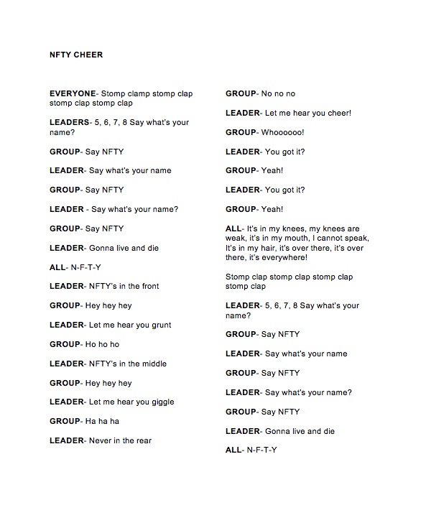
Name Tags

What is it?
-A means of identification for the duration of the event.

Who was it created for?
-NFTYites

Who created it?
-Event staff

When is it used?
-The entire duration of a regional Kallah

What is the purpose of it?
-So people know who you are and that you are a part of the event.

Put it all together
-Nametags are these wonderful things every participant must wear for the duration of any regional or national event. They say your name, your TYG, the Region of the event and the date. On the back of everyone’s nametags, there are program numbers with places the program will take place. This helps all the NFTYites know where to go for each activity. A new nametag is given at each event, so by the time you are a senior, you have accumulated a good number of them, and when you go to your last event, you bring all of the nametags you have received over the years!

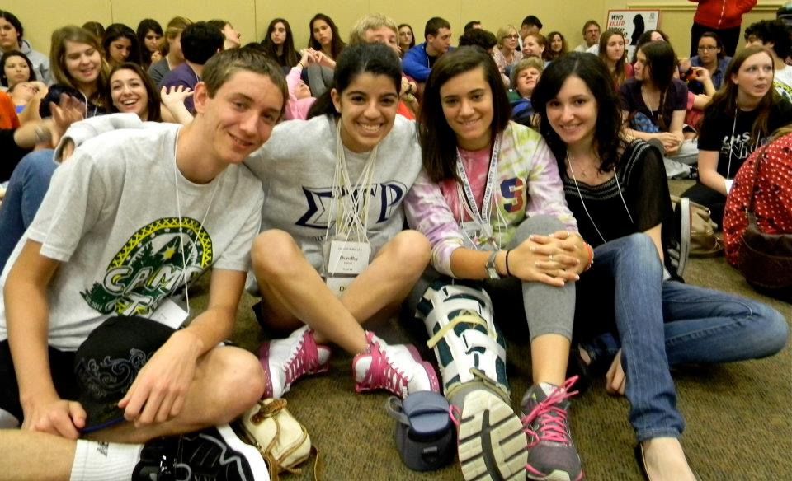
*A couple seniors at their last Kallah with all of their nametags

Chai 5

What is it?
-A newspaper of the happenings for the day, and a story or two written by NFTYites targeted at new NFTYites to try to hook them in NFTY

Who was it created for?
-NFTYites

When is it used?
-Each morning during a regional Kallah

What is the purpose of it?
-There are a couple of reasons the Chai 5 is used. One is to get the schedule of the day out to all the NFTYites, and I think the second is to tell stories make an impact…

Put it all together
-Each morning of an event, NFTYites receive a Chai 5. The Chai 5 is in a way like a mini newspaper. While it has the times for the day’s happenings, it also has articles written by NFTYites for NFTYites. The articles are more stories about how great NFTY is, and I was honored when I was asked to write one for NFTY-STR’s Winter Kallah in 2011.

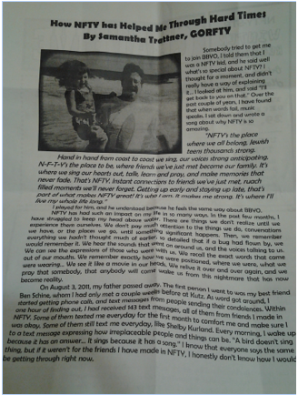
*Chai 5 Article

Brit Kehillah

What is it?
-Code of conduct that NFTYites must follow when attending an event.

Who was it created for?
-The Brit Kehillah was created for NFTYites.

Why was it created?
-To make NFTYites aware of what will not be tolerated at events.

When is it used?
-Before any event, every NFTYite, and their parent or guardian must sign the Brit Kehillah, as a confirmation that they read it.

How has it changed over time? (How has it changed between the regions?)
-The Brit is the same for all regions it has probably been tweaked over the years to make it more up-to-date.

What does it represent?
-I think it represents a promise.

What is the purpose of it?
-The reason we use the Brit is to insure the health and safety of all participants at NFTY events, and to let it be known what behaviors will not be tolerated.

Put it all together
-The Brit Kehillah is the Code of conduct that NFTYites must follow when attending an event. It was created for the NFTYites to make them aware of what will and will not be tolerated at events. The Brit is the same for all regions and has probably been tweaked over the years to make it more up-to-date. Things that we have access to now may not have been around 70 years ago when NFTY was created. Before any event, every NFTYite, and their parent or guardian must sign the Brit Kehillah, as a confirmation that they read it. The reason we use the Brit is to insure the health and safety of all participants at NFTY events, and to let it be known what behaviors will not be tolerated.

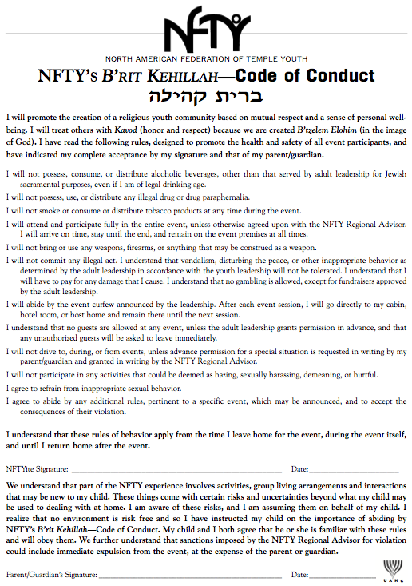
*Picture of the Brit Kehillah

Senior Shoe

What is it?
-The “Senior Shoe” is a tradition done at the last Siyuum circle at each Kallah during a NFTYite’s senior year. During the closing song, all the seniors take off their shoes, and throw them in the middle of the circle.

Who was it created for?
-All of the senior NFTYites.

Who created it?
-It was probably created by a group of seniors.

When is it used?
-During the last Siyuum circle, during the closing song.

What does it represent?
-A journey through exploring ones Judaism

What is the purpose of it?
- Closing a chapter, opening another….

Put it all together
-The “Senior Shoe” is a tradition done at the last Siyuum circle at each Kallah during a NFTYite’s senior year. During the closing song, all the seniors take off their shoes, and throw them in the middle of the circle. It was created for senior NFTYites. I think that this tradition represents a journey, a journey through the exploration of ones Judaism. It’s a shoe, it has been worn many places in the past, and will be worn many places in the future, in a way, it is like a marker. It has marked our footprints through life. I think that the reason people do it is to “show” where they have been, where they walked, where they left footprints, and an impact… But because it’s done at the end of the Kallot, I think it symbolizes the closing of one chapter in somebodies life, and the opening/ start of another.
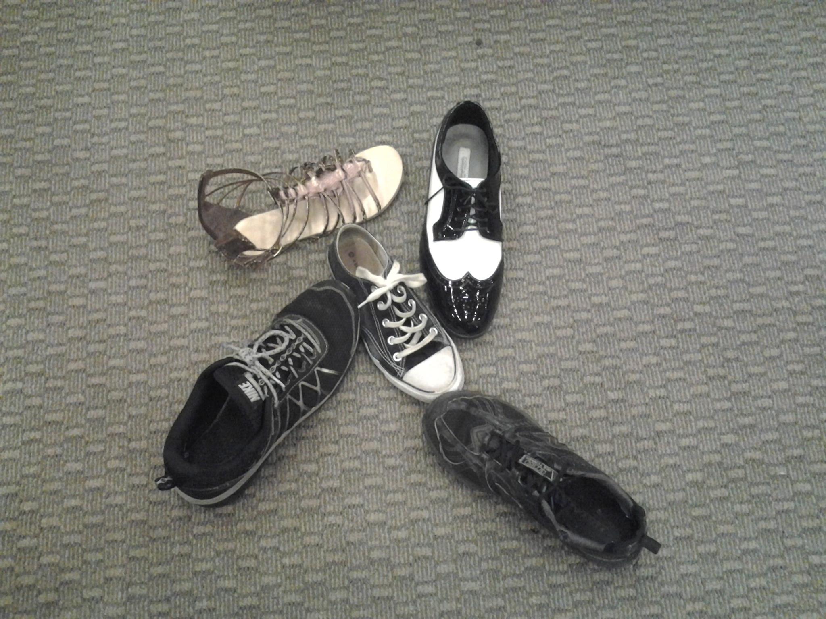
*Senior Shoe at a GORFTY Event

